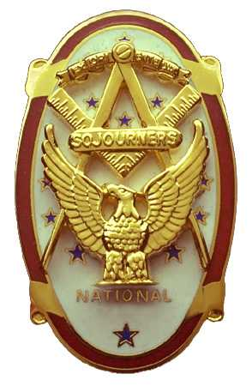 | Olympic Chapter No. 539,  National Sojourners  and  Marvin Shields Camp of Heroes of ‘76 |  |  | 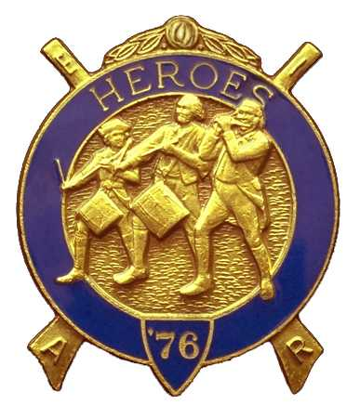
S. Steve Seteroff  Secretary-Treasurer |  |  | PO Box 847  Quilcene, WA 98376
seteroff@earthlink.net |  | http://www.telebyte.com/masons/sojourn/ | (360) 765-3050

September 22, 2004

Thirteen members and guests gathered at the Paradise Restaurant in Sequim for lunch and camaraderie.

As is our custom, we began with a Toast to the Flag, delivered by Br. Fred Johnson.

President John Jones opened the chapter meeting with Br. Franklin Benson attending the Bible.

We remain solvent and the treasury stands at $683.83, with approximately $250 of this committed to flagpoles and tops that are ordered, and $100 from ticket sales for the dining out.

No Bridge of Light or Americanism programs were performed since the last meeting, as most lodges were still dark.

Commitments for the October 27 Dining Out event are trickling in slowly and it is clear that we will need to find an alternate location with a more favorable price.

Our attendance at Pacific Beach for the Area Encampment looks solid with ten committed at this time and two verifying their schedule to ensure they can attend. We anticipate fielding a solid representation with more than half in colonial uniforms.

Following announcements, door prizes were awarded and the raffle raised $55 to assist in our activities. Thank you to all who participated.

Br. Steve Seteroff honored our closing custom by delivering the Old Glory monologue. Following which, the meeting was closed by President John Jones with Br. Franklin Benson attending the Bible,

Our next meeting will be the Dining Out at 1800 on Wednesday, October 27, 2004 at the Dungeness Bay Golf and Country Club at 1965 Woodcock Road, in Sequim.

We broke formality and many of the brethren and guests engaged in dialogue and camaraderie before proceeding on our usual pursuits.

Steve Seteroff
Secretary

