 | Olympic Chapter No. 539,  National Sojourners  and  Marvin Shields Camp of Heroes of ‘76 |  |  | 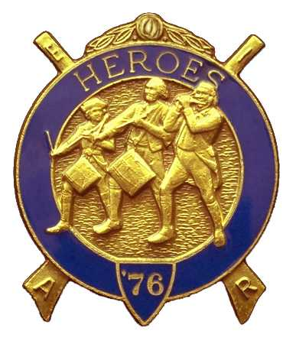
S. Steve Seteroff  Secretary-Treasurer |  |  | PO Box 847  Quilcene, WA 98376
seteroff@earthlink.net |  | http://www.telebyte.com/masons/sojourn/ | (360) 765-3050

August 25, 2004

Twenty-six members and guests gathered at the Paradise Restaurant in Sequim for dinner and camaraderie.

As is our custom, we began with a Toast to the Flag, delivered by Br. Fred Johnson.

President John Jones opened the chapter meeting with Br. Steve Seteroff attending the Bible.

We remain solvent and the treasury stands at $844.60, with approximately $325 of this committed to the chapter flag that is ordered.

Br. Fred Johnson resented the Marvin Shields Camp Commanders Aware of Excellence to Br. Ed Marion for his work in fostering Americanism and Patriotism.

Br. Ed Marion reported two Americanism performances since our last meeting and Br. David MacNeill reported that no Bridge of Light events were held because most lodges are currently dark. Br. Don Patrick was not present to report on membership, but we continue our planning for the October 27 Dining Out event.

Br. Jones introduced Bet Houston who led us through a recent map of archeological sites in Israel and related her experiences at several of the archeological digs over the past several years. The presentation was again very well received and resulted in several requests to bring her back for an encore presentation. We do hope that she will consider a return favorably.

Following announcements, door prizes were awarded and Br. Clarence Johnson reported that the raffle raised $65 to assist in our activities. Thank you to all who participated.

Br. Clarence Johnson honored our closing custom by delivering the Old Glory monologue. Following which, the meeting was closed by President John Jones with Br. Steve Seteroff attending the Bible,

Our next meeting will be at 1200 on Wednesday, September 22, 2004 at the Paradise Restaurant in Sequim.

It is not too late to send in your registration to attend the Annual Area Encampment at Pacific Beach on October 8-10. All Sojourners, their ladies, and guests, are invited to attend.

We broke formality and many of the brethren and guests engaged in dialogue and camaraderie before proceeding on our usual pursuits.

Steve Seteroff
Secretary

