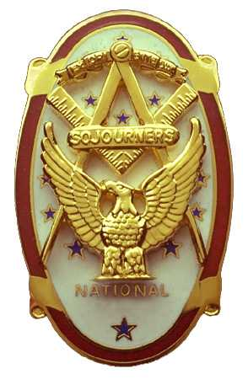 | Olympic Chapter No. 539,  National Sojourners  and  Marvin Shields Camp of Heroes of ‘76 |  |  | 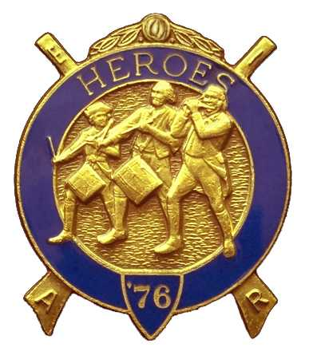
S. Steve Seteroff  Secretary-Treasurer |  |  | PO Box 847  Quilcene, WA 98376
seteroff@earthlink.net |  | http://www.telebyte.com/masons/sojourn/ | (360) 765-3050

July 28, 2004

Eighteen members and guests gathered at the Paradise Restaurant in Sequim for lunch, followed by a brief business meeting.

As is our custom, we began with a Toast to the Flag, delivered by Br. Fred Johnson.

President John Jones opened the chapter meeting with Br. Franklin Benson attending the Bible. We remain solvent and the treasury stands at $513.60.

Br. Ed Marion reported on Americanism; Br. David MacNeill reported on Bridge of Light; and Br. Don Patrick reported on membership and announced a Dining Out for our meeting on October 27.

The evening meeting of October 27 will probably be held at another venue due to the size limitation of 46 guests in the Paradise. Br. Franklin Benson is working to find a suitable location in Sequim that can accommodate us as well as provide a table lodge, or formal dining, like setting. This event will be used to encourage new members, as well as provide a fun evening for our members and ladies, so Don Patrick will be working very closely with Franklin to ensure we have a successful event.

Because the national convention approved an increase of per capita dies of $5.00, and in consonance with our by-laws, our chapter dues next year will be $28.00. Members who have taken out an MIP are not affected by this dues increase. This presents an excellent opportunity for annual dues paying members to take out a Membership in Perpetuity before the cost of that too is increased next year, as suspected. The current cost of a MIP is $200.00 for the first membership and $150.00 for other chapters of which you may be a member and wish to support. Should you desire to become a MIP, just make out a check for the appropriate amount and send it to me, or directly to national, stating your intent to become a MIP in Olympic 539 and I will take care of the rest.

Br. Wendell Dutt, our Regional Representative presented the heroes of ’76 Award of Excellence to Br. Fred Johnson for his work during the past year and the Presidential Citation to Br. Steve Seteroff.

Br. Joseph Illes instigated an avalanche of contributions for our chapter flag fund and as a direct result of the outpouring of support our flag fund now stands at $230.00. Thank you so much for the barrow-wheeling effort Joseph. The secretary will contact national to determine current costs.

Following announcements, door prizes were awarded and Br. Ed Marion reported that the raffle raised $75.00 to assist in our activities. Thank you to all who participated.

Our next meeting will be at 1800 on Wednesday, August 25, 2004 at the Paradise Restaurant in Sequim and Bet Houston will be our guest speaker. We enjoyed her presentation so much in June of 2003 that we have asked her back by request of several of our members and many of our ladies. Bett is returning to speak on archeological activities in the Middle East.

Br. President John Jones closed the meeting with Br. Franklin Benson attending the Bible.

Br. John Jones delivered the Old Glory Monologue.

We broke formality and many of the brethren and guests engaged in dialogue and camaraderie before proceeding on our usual pursuits.

Steve Seteroff
Secretary

