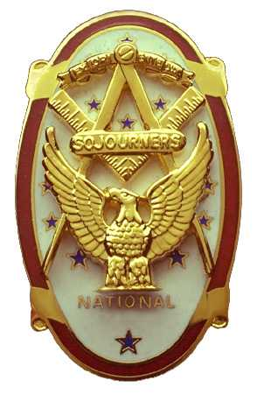 | Olympic Chapter No. 539,  National Sojourners  and  Marvin Shields Camp of Heroes of ‘76 |  |  | 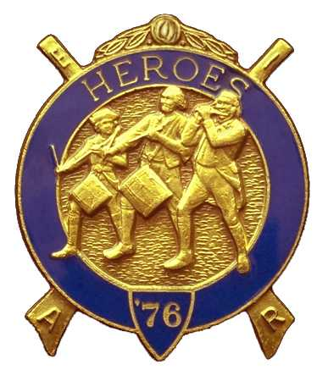
S. Steve Seteroff  Secretary-Treasurer |  |  | PO Box 847  Quilcene, WA 98376
seteroff@earthlink.net |  | http://www.telebyte.com/masons/sojourn/ | (360) 765-3050

June 23, 2004

Twenty-two members and guests gathered at the Paradise Restaurant in Sequim for dinner and camaraderie.

As is our custom, we began with a Toast to the Flag, delivered by Br. Fred Johnson.

President John Jones opened the chapter meeting with Br. Franklin Benson attending the Bible. He then introduced Br. Ben Bena who spoke of his involvement with emergency management during the Mount St. Helens eruption and fielded several questions from the audience. President John Jones presented Br. Ben Bena with a certificate of appreciation

We remain solvent and the treasury stands at $497.43.

Br. Ed Marion reported nine Americanism performances since our last meeting and Br. David MacNeill reported five Bridge of Light events. Br. Don Patrick continues to work on membership.

We were pleased to induct LCDR John Rowe Richardson, MD and, as a courtesy to our sponsoring chapter Sinclair Inlet, Charles “Chuck” Compton. Two fine additions to our respective chapters.

Br. Wendell Dutt, our Regional Representative, delivered a brief summary of his experiences and the legislation at the national conference, just completed. The most significant issue is an increase of the national per-capita by $5.00, which will necessitate some action on our part before it goes into effect on January 1, 2005. He then surprised, and delighted, us by presenting Marvin Shields Camp with the prestigious Jonathan M. Wainwright Award for Outstanding Camp for the year 2003-2004. Don Patrick as the immediate past Camp Commander accepted the award on behalf of the Camp. We are, of course, very proud to win this award I the first year of our existence.

Following announcements, door prizes were awarded and Br. Don Patrick reported that the raffle raised $115 to assist in our activities. Thank you to all who participated.

Following closure of the meeting by President John Jones with Br. Franklin Benson attending the Bible, Br. Clarence Johnson honored our custom by delivering the Old Glory monologue.

Our next meeting will be at 1200 on Wednesday, July 28, 2004 at the Paradise Restaurant in Sequim.

There will be an Encampment of Heroes, with Thomas Casey Camp, at 1300 on Saturday, July 10, 2004 at the Quilcene Masonic Hall. All heroes are urged to contact COS Ed Marion to volunteer for a part in the degree.

We broke formality and many of the brethren and guests engaged in dialogue and camaraderie before proceeding on our usual pursuits.

Steve Seteroff
Secretary

