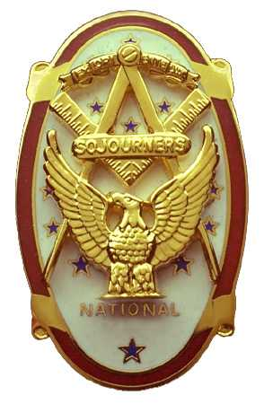 | Olympic Chapter No. 539,  National Sojourners  and  Marvin Shields Camp of Heroes of ‘76 |  |  | 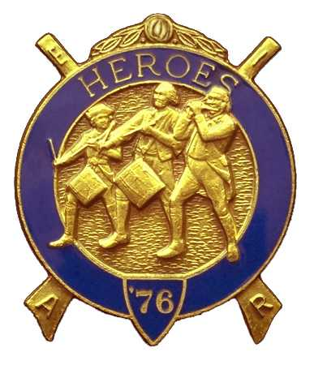
S. Steve Seteroff  Secretary-Treasurer |  |  | PO Box 847  Quilcene, WA 98376
seteroff@earthlink.net |  | http://www.telebyte.com/masons/sojourn/ | (360) 765-3050

May 26, 2004

Sixteen members and guests gathered at the Paradise Restaurant in Sequim for lunch, followed by a brief business meeting.

As is our custom, we began with a Toast to the Flag, delivered by Br. Fred Johnson.

President Dee Yager opened the chapter meeting with Br. Franklin Benson attending the Bible. We remain solvent and the treasury stands at $470.66.

We were pleased to elect LCDR John Rowe Richardson, MD to membership. He will be initiated at our June 23 meeting.

Following announcements, door prizes were awarded and Br. Clarence Johnson reported that the raffle raised $60 to assist in our activities. Thank you to all who participated.

Our next meeting will be at 1800 on Wednesday, June 23, 2004 at the Paradise Restaurant in Sequim.

Br. President Dee Yager closed the meeting with Br. Franklin Benson attending the Bible.

Br. S. Steve Seteroff delivered the Old Glory Monologue.

We broke formality and many of the brethren and guests engaged in dialogue and camaraderie before proceeding on our usual pursuits.

Steve Seteroff
Secretary

