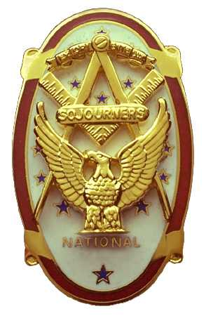 | Olympic Chapter No. 539,  National Sojourners  and  Marvin Shields Camp of Heroes of ‘76 |  |  | 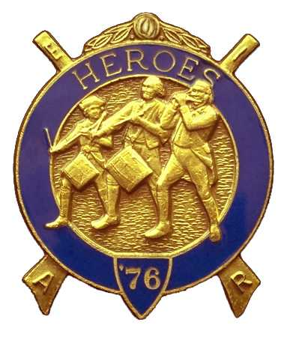
S. Steve Seteroff  Secretary-Treasurer |  |  | PO Box 847  Quilcene, WA 98376
seteroff@earthlink.net |  | http://www.telebyte.com/masons/sojourn/ | (360) 765-3050

April 28, 2004

Forty-seven members and guests Gathered at the Paradise Restaurant in Sequim to celebrate our first full year as a chapter. Br. Fred Johnson arranged for musical entertainment by Nostalgia, and joined them in providing live music during our social hour and dinner.

As is our custom, we began with a Toast to the Flag, delivered by Br. Fred Johnson. President Dee Yager opened the chapter meeting with Br. Franklin Benson attending the Bible. We remain solvent and the MIP Dividend of $106.40 was a most welcome addition to our coffers. The treasury stands at $504.41 and was reported in the reading folder to free the celebration of distractions from routine business.

Introduction of visitors was dispensed with. President Dee Yager recognized the sponsorship of our parent chapter, Sinclair Inlet No. 80, and presented certificated to President Graham Kent and Secretary Harold Richardson. A certificate of appreciation was presented to Br. Joseph Illes, whose tutelage and active assistance ensured our success.

We were pleased to induct Br. Paul J. Carmean into the Chapter, with the medal lecture and charge being delivered from memory by Br. Don Patrick.

Br. Stanley C. Miller, National Chief of Staff offered some remarks and represented the National officers at this celebration.

MW James N. Reid, Jr., Past Grand Master of F&AM of Washington, who presented our charter on behalf of National Sojourners last year spoke about the effect of our organization on the youth of our communities and in Masonry by furthering patriotism and Americanism.

The results of the written ballot for officers for the Sojourner Year 2004-2005 were announced as follows:

Olympic Chapter No. 539

President: John Jones 3rd VP Ed Marion
1st VP: David MacNeill Chaplain: Franklin Benson
2nd VP: Don Patrick Secretary: S. Steve Seteroff

Marvin Shields Camp

Commander: Fred Johnson OOD David Larson
COS: Ed Marion Chaplain: Franklin Benson
Adjutant: S. Steve Seteroff

The raffle raised a total of $130 to assist in our activities. Thank you to all who participated.

Our next meeting will be at 1200 on Wednesday, June 23, 2004 at the Paradise Restaurant in Sequim.

Br. President Dee Yager closed the meeting with Br. Franklin Benson attending the Bible.

Br. S. Steve Seteroff delivered the Old Glory Monologue.

We broke formality and many of the brethren and guests engaged in dialogue and camaraderie before proceeding to our usual pursuits.

Steve Seteroff
Secretary

