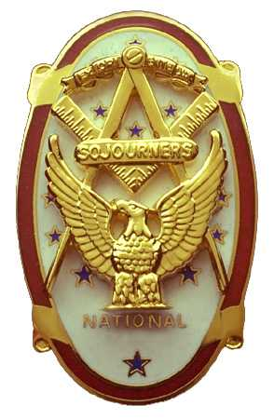 | Olympic Chapter No. 539,  National Sojourners  and  Marvin Shields Camp of Heroes of ‘76 |  |  | 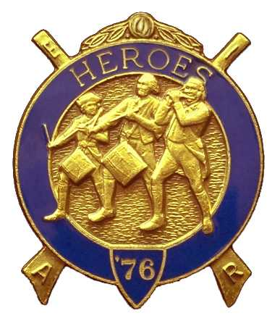
S. Steve Seteroff  Secretary-Treasurer |  |  | PO Box 847  Quilcene, WA 98376
seteroff@earthlink.net |  | http://www.telebyte.com/masons/sojourn/ | (360) 765-3050

March 24, 2004

Fourteen members and guests avoided the occasional rain showers and sporadic winds by gathering at the Paradise Restaurant in Sequim. As is our custom, following lunch, we began with a Toast to the Flag, delivered by Br. Fred Johnson. President Dee Yager opened the chapter meeting with Br. Franklin Benson attending the Bible. The treasury stands at $355.18. We remain solvent.

John Jones reported on Americanism and Bridge of Light events since our last meeting and updated our scheduled and tentative performances through the end of the calendar year. We delivered five performances since our previous meeting.

The Chapter nominating committee headed by Franklin Benson suggested that current officers succeed to the next position and recommended Don Patrick and Ed Marion compete for 2nd and 3rd Vice President.

The Camp nominating committee headed by Clarence Johnson recommended Ed Marion for Chief of Staff and Dave Larson for Officer of the Day.

We will host an encampment with Casey Camp of Pacific Northwest Chapter, and possibly one other, at 1300 on Saturday, June 28. Br. Fred Johnson will investigate a venue in Port Townsend and will coordinate shuttle service from the ferry landing.

Our Area Representative, Wayne Smith, is coordinating two initiatives and is seeking assistance in identifying:

- Members who have continental uniforms who will be attending Grand Lodge and willing to participate in a color guard

- Members with continental uniforms who would be willing to serve on a MM degree team at the Outdoor MM Degree at Granite Falls in August 2005.

- Members who can fit into their uniforms, or are willing to purchase open collar uniforms for their service, and who are willing to participate in an area wide degree team to confer degrees on active duty military personnel.

The secretary will be pleased to collect this information from our members and consolidate it for forwarding to the Area Representative.

Br. Ed Marion delivered a well researched talk on Br. Marvin Glenn Shields, his early life in the area and his conduct under fire that earned for him the Medal of Honor.

Since no other member present will attend the Sojourner convention at Fayetteville, Wayne Smith will represent our chapter.

The raffle raised a total of $80 to assist in our activities and an additional $5 in donations was added to the treasury. Thank you to all who participated.

Our next meeting will be at 1800 on Wednesday, April 28, 2004 at the Paradise Restaurant in Sequim. MW James N. Reid Jr., PGM will be our guest speaker on this first anniversary of our charter and we will be pleased to welcome our National Chief of Staff Stanley Miller who will journey from Oregon for the occasion. We are excited that Br. Fred Johnson was able to arrange live music for this evening, and will join the band as a performer. Reservations are essential as the room is limited and seating arrangements must be coordinated well in advance. Please telephone Franklin Benson at (360) 582-9007 or better yet, send him an email at f.benson@att.net to reserve your seats at the table. Again, reservations are essential, and as soon as possible please.

Br. President Dee Yager closed the meeting and we disbanded to go our separate ways.

Steve Seteroff
Secretary

