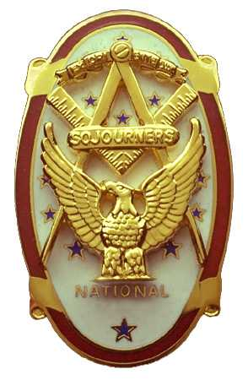 | Olympic Chapter No. 539,  National Sojourners  and  Marvin Shields Camp of Heroes of ‘76 |  |  | 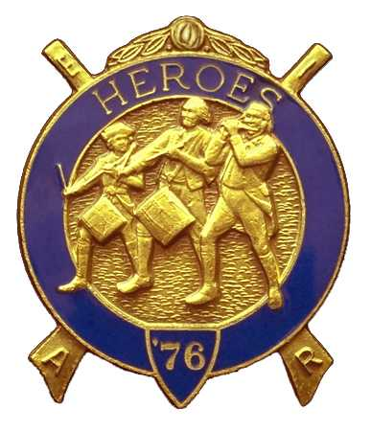
S. Steve Seteroff  Secretary-Treasurer |  |  | PO Box 847  Quilcene, WA 98376
seteroff@earthlink.net |  | http://www.telebyte.com/masons/sojourn/ | (360) 765-3050

February 25, 2004

Nineteen members and guests avoided the usual rain showers by gathering at the Paradise Restaurant in Sequim. As is our custom, following dinner, we began with a Toast to the Flag, delivered by Br. Fred Johnson. President Dee Yager opened the chapter meeting with Br. Franklin Benson attending the Bible. The treasury stands at $312.70. We are solvent.

We were honored to receive Maj. Leo Campbell, USMC (Ret.) the new OInC of the NJROTC Detachment at Port Angeles High School. He enlightened us about the progress made in expanding the detachment and confirmed our participation in awarding the National Sojourner ROTC Award for Americanism on May 15. We were also delighted to learn that our 2003 Sojourner Medal recipient Cadet CPO Robert Springer has been promoted and is now a Lieutenant. We will invite Robert Springer with the new recipient to our June meeting.

Fred Johnson reported on Americanism program activities and John Jones addressed the bridge of Light events. We delivered eleven performances since our previous meeting and have several performances scheduled and some pending firm dates.

We gained RW David P. Owen as an MIP and elected CPO/USCG Paul J. Carmean, sponsored by David Larson, to membership. He will be inducted at the April meeting since he will be unable to attend the luncheon meeting in March.

President Dee Yager appointed a nominating committee consisting of Franklin Benson, Don Patrick, and Don Clark who will report a slate of officers at the March meeting.

The raffle raised a total of $28 to assist in our activities and an additional $10 in donations was added to the treasury. Thank you to all who participated.

Our next meeting will be at noon on Wednesday, March 24, 2004 at the Paradise Restaurant in Sequim.

Old Glory monologue ended our meeting.

Steve Seteroff
Secretary

