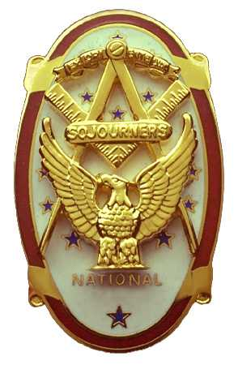 | Olympic Chapter No. 539,  National Sojourners  and  Marvin Shields Camp of Heroes of ‘76 |  |  | 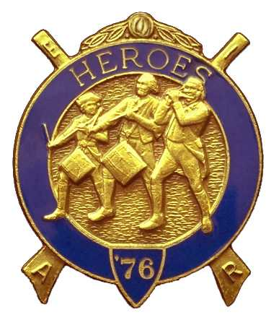
S. Steve Seteroff  Secretary-Treasurer |  |  | PO Box 847  Quilcene, WA 98376
seteroff@earthlink.net |  | http://www.telebyte.com/masons/sojourn/ | (360) 765-3050

December 17, 2003

Eighteen members and guests celebrated a clear and pleasant evening by gathering at the Paradise Restaurant in Sequim. As is our custom, following dinner, we began with a Toast to the Flag, delivered by Br. Fred Johnson. President Dee Yager opened the chapter meeting with Br. Franklin Benson attending the Bible. The treasury stands at $233.57. We are solvent.

Fred Johnson reported on Americanism program activities and John Jones addressed the bridge of Light events. We delivered five performances since our November meeting. We have no scheduled performances before our January scheduled meeting but do have performances in February. Dave MacNeill reported the status of our membership activities.

President Dee Yager reported that the Memorial MIP and Widows Certificate has been delivered to Carol Foss. Clarence Johnson presented to the chapter a miniature set of flags he acquired on his recent trip around the United States. The set includes the Flag of the United States, Betsy Ross flag, Bennington Flag, Don’t Tread on Me and Pine Tree flags.

Mr. Don Perry spoke with considerable passion about the Port Angeles Underground, the historical necessity for raising the street level above the high tides, and the methodology used. He went into the politics, displayed a number of photographs from the period, and explained the significance of many of the events, methods, and processes used. He then invited our organization to take advantage of tours at our leisure, as long as we do so in groups of five to nine. If you would like to take this tour, please contact Louanne Yager to schedule your group. The cost will be $5 per person. President Dee Yager presented a certificate of appreciation to Don Perry.

The raffle raised a total of $39 to assist in our activities. Thank you to all who participated. Wendell Dutt, our regional representative was unable to attend but sent his greetings.

Our next meeting will be at noon on Wednesday, January 28, 2004 at the Dungeness Golf and Country Club, 1865 Woodcock Road, in Sequim.

Br. John Jones delivered the Old Glory monologue to end our meeting.

Steve Seteroff
Secretary

