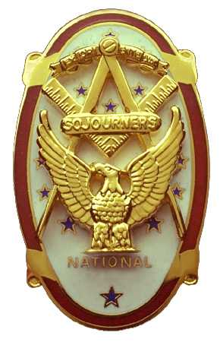 | Olympic Chapter No. 539,  National Sojourners  and  Marvin Shields Camp of Heroes of ‘76 |  |  | 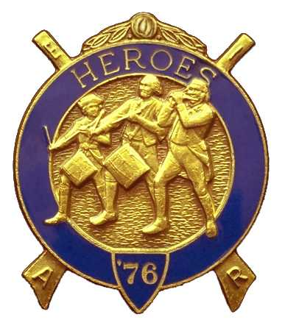
S. Steve Seteroff  Secretary-Treasurer |  |  | PO Box 847  Quilcene, WA 98376
seteroff@earthlink.net |  | http://www.telebyte.com/masons/sojourn/ | (360) 765-3050

November 19, 2003

In spite of snow storms in the Seattle Area, and heavy winds and rains on the peninsula, the weather broke nice for our meeting at the Three Crabs in Dungeness. As is our custom, following luncheon, we began with a Toast to the Flag, delivered by Br. Fred Johnson.

President Dee Yager opened the chapter meeting with Br. Franklin Benson attending the Bible. The treasury stands at $100.37 with some outstanding accounts payable and receivable. We are solvent.

Fred Johnson reported that there were four performances for the Bridge of Light and three Americanism programs presented by the Marvin Shields Camp since our October meeting. We currently have one Bridge of Light performance scheduled before our next scheduled meeting.

As many as possible should make an attempt to attend the 2004 Area Encampment on October 8-10. Registrations are now open and you can make lodging reservations directly with Pacific Beach by calling 1-888-463-6697.

The raffle raised a total of $59 to assist in our activities. Thank you to all who participated.

Br. John Vai is in the interview process for entry into the Masonic Retirement Center and we asked Wendell Dutt, Secretary of the Fort Lewis Chapter, to include him in their periodic visits.

President Dee Yager displayed our first award streamer, 100% 3-6-5 Award. Congratulations and thank you to all who contributed so generously to achieve this award.

Our next meeting will be at 1800 on Wednesday, December 17, at the Paradise Restaurant in Sequim.

Br. John Jones delivered the Old Glory monologue to end our meeting.

Steve Seteroff
Secretary

