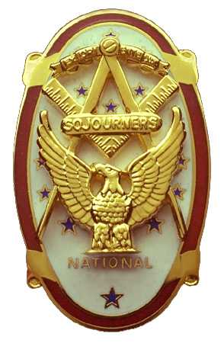 | Olympic Chapter No. 539,  National Sojourners  and  Marvin Shields Camp of Heroes of ‘76 |  |  | 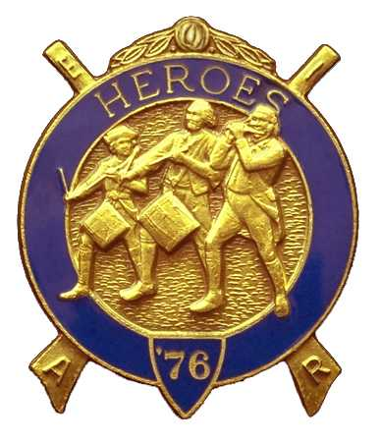
S. Steve Seteroff  Secretary-Treasurer |  |  | PO Box 847  Quilcene, WA 98376
seteroff@earthlink.net |  | http://www.telebyte.com/masons/sojourn/ | (360) 765-3050

October 22, 2003

Twenty-six members and guests braved the multiple road closures and the unseasonable heavy rains to gather for this meeting. As is our custom, following diner, we began with a Toast to the Flag, delivered by Br. Fred Johnson. Since our guest speaker June Robinson was on a tight schedule, we were pleased to have her presentation before the meeting began. Ms Robinson spoke on the Michigan Soldiers Colony consisting of Civil War Veterans who came to the Port Angeles Area and became the movers and shakers of the community.

President Dee Yager opened the chapter meeting with Br. Franklin Benson attending the Bible. The treasury stands at $130.66 with some outstanding accounts payable and receivable. We are solvent. Fred Johnson reported that there are three performances scheduled for November, and encouraged all who could make it to the Grand masters visit be there to support our presenting the Toast and the Building of the Flag.

We were pleased to induct Br. Paul Flewelling and Br. Edwin Marion, both sponsored by Br. Bud Porter. Camp Commander Don Patrick did a marvelous job of delivering the Medal Lecture. We raised sufficient funds to enable purchase of a Memorial MIP for our late Br. Ron Foss, our first Hero in Marvin Shields.

We were well represented at the annual encampment at Pacific beach this year. Olympic Chapter and Marvin Shields Camp will be the sponsor for the Area Encampment at Pacific Beach on October 7-9, 2005 and as many as possible should make an attempt to attend then, as well as during the October 8-10, 2004 Encampment. Registrations are now open for 2004 and you can make lodging reservations directly with Pacific Beach by calling 1-888-463-6697.

Dues notices have been mailed by National. Remember that dues are $20 and the SEM Fund contribution is $3.65 per year. Why not take advantage to purchase an MIP for $200 and a Life Membership in the SEM 3-6-5 Club for $36.50, and relieve yourself of this worry next year. Either way, please send your check to the secretary as soon as possible.

Our next meeting will be at Noon on Wednesday, November 19, at the Three Crabs Restaurant in Dungeness

Steve Seteroff
Secretary

