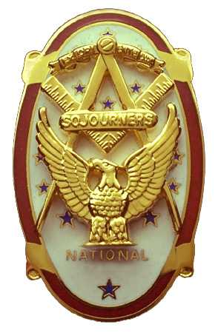 | Olympic Chapter No. 539,  National Sojourners  and  Marvin Shields Camp of Heroes of ‘76 |  |  | 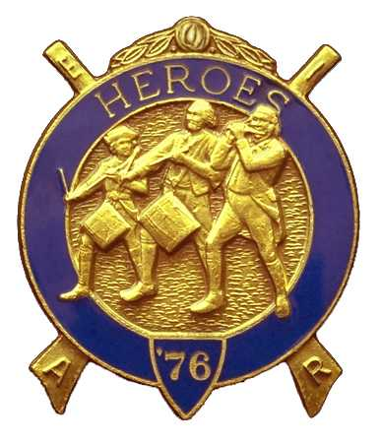
S. Steve Seteroff  Secretary-Treasurer |  |  | PO Box 847  Quilcene, WA 98376
seteroff@earthlink.net |  | http://www.telebyte.com/masons/sojourn/ | (360) 765-3050

May 28, 2003

As is our custom, following lunch, we began with a Toast to the Flag, delivered by Br. Fred Johnson.

President Clarence Johnson opened the chapter meeting with Br. Wendell Dutt attending the Bible. The treasury stands at $83.37

Fred Johnson reported performing the Toast to the Flag at the Port Townsend Methodist Church on Sunday, 25 May, 2003.

Dee Yager reported on the presentation of the Sojourner Medal to Cadet CPO Robert L. Springer of the Port Angeles High School NJROTC on Saturday 18 May, 2003 with several sojourners in attendance to support our presentation. Cadet Springer and his parents will be our guests at our next meeting at 1800 on Wednesday, June 25, 2003.

We were pleased to welcome Br. Ron Foss as the first Hero to be made in Marvin Shields Camp on May 24, 2003.

A raffle for a tabletop US Flag donated by Br. John Jones resulted in a gain to our treasure of $28.

Reservations for the Joint Installation of Officers at 1200 on Saturday, June 7 were taken. Announcements of Heroes Initiations at 1000 on Wednesday, June 18; and 1400 on Saturday, June 28 were made.

No further business appearing the formal portion of our meeting was closed by President Clarence Johnson with Br. Wendell Dutt attending the Bible. Good conversation and camaraderie continued until we parted to go our separate ways until our next meeting at 1800 on Wednesday, June 25, 2003 at the Red Ranch Restaurant when we will be pleased to welcome Cadet CPO Robert L. Springer our 2003 Sojourner Medal Winner, and our guest speaker Bett Houston.

Steve Seteroff
Secretary

