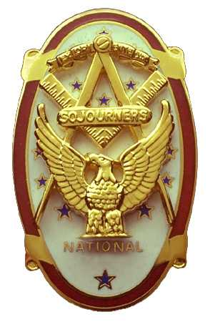 | Olympic Chapter No. 539,  National Sojourners  and  Marvin Shields Camp of Heroes of ‘76 |  |  | 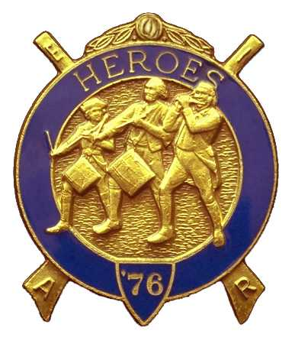
S. Steve Seteroff  Secretary-Treasurer |  |  | PO Box 847  Quilcene, WA 98376
seteroff@earthlink.net |  | http://www.telebyte.com/masons/sojourn/ | (360) 765-3050

Charter Night Summary
April 23, 2003

Following dinner, with 35 in attendance, Club President Clarence Johnson called on Br. Fred Johnson to begin the festivities by delivering the Toast to the Flag, as has become our custom. Clarence Johnson introduced our visitors:

MW James N. Reid, Jr. Sojourner and Hero, Grand Master of F&AM of Washington
Richard Williamson, National Commander, Heroes of ‘76
Joseph W. Illes, Northwest Area Representative
Wendell Dutt, Regional Representative
Wayne Smith, Regional Representative and DDGM F&AM of Washington, District 9
VW Arnie Finley, DDGMF&AM of Washington, District 11
W Michael Pursey, Junior Grand Steward, F&AM of Washington

Installation officers were
Joseph W. Illes for the Chapter and Wendell Dutt for the Camp
Wayne Smith, Regional Representative, as Marshall
Graham Kent, President of Sinclair Inlet Chapter and Lewis and Clark Camp as Chaplain
Harold Richardson, Secretary of Sinclair Inlet Chapter and Adjutant of Lewis and Clark Camp as Secretary and Adjutant

Joseph Illes installed Clarence Johnson as President, Dee Yager as 1st Vice President, John Jones as 2nd Vice President, Franklin Benson as Chaplain, and Steve Seteroff as Secretary of Olympic Chapter No. 539, National Sojourners. Grand Master James N. Reid, Jr. presented the charter to Clarence Johnson.

Joseph Illes presented a Memorial Membership in Perpetuity to be held for delivery to the family of our deceased brother.

Wendell Dutt installed Don Patrick as Commander, Fred Johnson as Chief of Staff, Franklin Benson as Chaplain, and Steve Seteroff as Adjutant of Marvin Shields Camp of Heroes of ’76. National Commander Richard Williamson presented the Camp Charter to Commander Don Patrick.

We were pleased to receive a few comments from our National Commander, Richard Williamson who remarked on his recent trip to visit the camps in Hawaii and enlightened us on the efforts to place a National Sojourners Plaque on the USS Missouri. He delivered his check as the first SEM 3-6-5 member of our chapter. Camp Commander Don Patrick presented our National Commander with a Certificate of Appreciation for his participation.

Our Grand Master honored us with his observations and we were both enlightened and entertained by his always eloquent and humorous delivery. He spoke of the current efforts to restore Masonry in our jurisdiction and explained the relationship of the several organizations and efforts. Chapter President Clarence Johnson presented our Grand Master with a Certificate of Appreciation for his efforts on behalf of National Sojourners and our organization in particular.

The festivities ended with delivery of Old Glory Speaks by Steve Seteroff.

Following our harmonious intercourse we adjourned to gather again at Noon on Wednesday, May 28, 2003 at the Red Ranch Restaurant in Sequim Washington.

Not announced at the Charter Night Festivities was our statement of account. At the time of starting this event, our account stood at a balance of $128.13 with no bills outstanding.

Steve Seteroff
Secretary

