
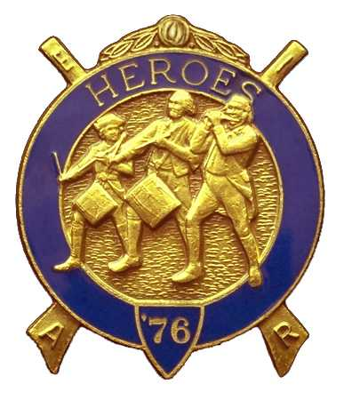
Olympic Chapter No.539
National Sojourners
And
Marvin Shields Camp of Heroes of ‘76
Vol 1 No. 3 March 26. 2008
CHAPTER AND CAMP OFFICERS
OLYMPIC chapters MARVIN G. SHIELDS CAMP
President- Fred Johnson – (360) 385-3130 Commander David Mac Neill - (360) 428-8710
fjohnson_30@q_.com dakamac@verizon.net

1st Vice President. – Darel E. Maxfield, Sr.-(360) 374-9330 Chief of Staff – Albert “bud” Porter – (360) 385—3228
maynard@olypen.com melsue@cablespeed..com

2nd Vice President- Morris E. “Mike” Moug- (360)385-4907 Asst. Ch. Of Staff-Paul J. Carmean – (360) 928-3385
mecom@olypen.com p.carmean@att.net

3rd Vice President – David J. Larson - (360) 457-9444 OOD- Robert K. “Bob” Clubb – (360) 765-3419
noseyjoe@olypen.com robertkclubb@hotmail.com

Chaplain – Clarence Johnson – (360) 385-6986 Chaplain – Clarence Johnson - (360) 383-6986
cjohnson@olypen.com cjohnson@olypen.com

Secretary/Treasurer – Edwin C. Marion - (360) 374-6777 Adjutant - Edwin C. Marion – (360) 374-6777
edwin028@centurytel.net edwin028@centurytel.net

DEP AREA REPRESENTATIVE
Wendell Dutt-(253) 565-5264 wadutt@comcast.net
OLYMPIC CHAPTER NO.539 WILLBE MEETING AT NOON ON MARCH 26TH AT THE PARADISE RESTAURANT IN SEQUIM. GRIP-N-GRIN WILL START AT 1200 HOURS AND LUNCH AT ABOUT 1245 HOURS. OUR NEXT BIVOUAC WILL BE AT THE CALL OF OUR COMMANDER.
_______________________________________________________________________
LUNCH MENU of our next meeting, but I do know that
one is being planned for later this Spring.
Being that we meet and eat at the Paradise
Restaurant Sequim, you may have what your If any Heroes has given the “Toast to the
heart desires by ordering from their Flag”, “Old Glory Speaks”, or any of our
house menu. The restaurant is located other types of activities, please let me
on Sequim Avenue across from the play know so I can put it in our records.
ground at Sequim High School. Parking is
no problem. There is a large parking lot SPEAKERS PROGRAM
plus lots of street parking. For those
planing to attend, please let Frank Benson At this time we don't have a Guest Speaker
know by e-mail at flben9007@msn.com. Scheduled, but I am sure President Fred
Johnson will come up with something,
HEROES CAMP NEWS like he did the meeting in January.
He asked that we tell somet funny story
As I havn't heard from our Camp that happened to us. Was lots of fun.
Commander I can't give you a date
COMING EVENTS FROM HEADQUARTERS

Joint installation of officers for all NW We have two new members in our ranks.
Chapters will be held on 7 June at the They are Cpl. (H) Darel E. Maxfield Jr.
Des Moines Masonic Temple. This will SFC Henry (Hank) P. Liendecker,
start with lunch ten followed by the retired US Army. Welcome aboard!.
Installation.
One of the easiest ways to get out of
Chapter meetings will be held for the paying duers is to get an MIP,
month of March with #40 VADM Homer Membership-In-Perpetuity. As of this
N. Wallin, PM on the 20th; #80 Sinclair- writing, the MIP is still only $200.00,
Inlet at the Bremerton Elks on PM the but for how long. There is a movement
14th; #89 Meriwether Lewis PM on the afoot to increase the price of a MIP.
25th; #534 Pacific Northwest, noon on the Also, the SEM, Sojourners Endowment
26th; and #539 Olympic, noon on the 27th. Fund, which is our charity fund. We
obligated to contribute $3.65 per year,
Election of off icers will be coming up just one penny a day, or you can also
before we know it. If any of our members get a life membership in that for only
wish to to go into the line , make your $36.50. With a life membership you
wishes come true by informing the have no worries.
Nomination Committee. I'm sure they
will find a job for you. DID YOU KNOW?

That the Pacific Northwest Area has a
website? Visit it!
www.telebyte.com/masons/sojourn/index.htm

ATTEND YOUR BLUE LODGE AND OTHER MASONIC ORGINIZATIONS

#69 PA, 11 March; #6 PT, 12 March; #213 Sequim, 13 March; Olympic Shrine Club
15 March; York Rite Bodies 19 March; DeMolay PA, and Rainbow, Sequim; Rainbow PA, 20th March; 22 March DEAM, Forks; 24 March Esther OES, PA;
24 March, Rainbow, PT; 26 March DeMolay, Sequim

